**PROBLEMS DURING INTERNET FAILURE**

1. How internet failure would affect some of your school activities?

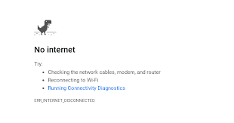_______________________________________

_______________________________________

_______________________________________

_______________________________________

_______________________________________

_______________________________________

________________________________________________________________

________________________________________________________________

1. How hospitals may be affected if there is no internet access?

_______________________________________

_______________________________________

_______________________________________

_______________________________________

_______________________________________

_______________________________________

________________________________________________________________

________________________________________________________________

1. 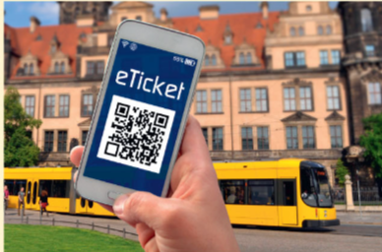How transport system would be affected due to internet failure?

_______________________________________

_______________________________________

_______________________________________

_______________________________________

_______________________________________

1. You get up one morning and realize that there is not working. You hear on the news that there would be no internet access for few days.

Write a short letter to your friends explaining any three difficulties you and your family would encounter during the days without internet access.

________________________________________________________________

________________________________________________________________

________________________________________________________________

________________________________________________________________

________________________________________________________________

________________________________________________________________

________________________________________________________________

________________________________________________________________

________________________________________________________________

________________________________________________________________