Maisie and George

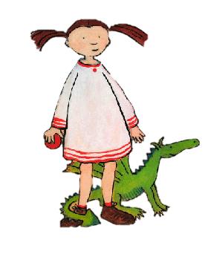 | 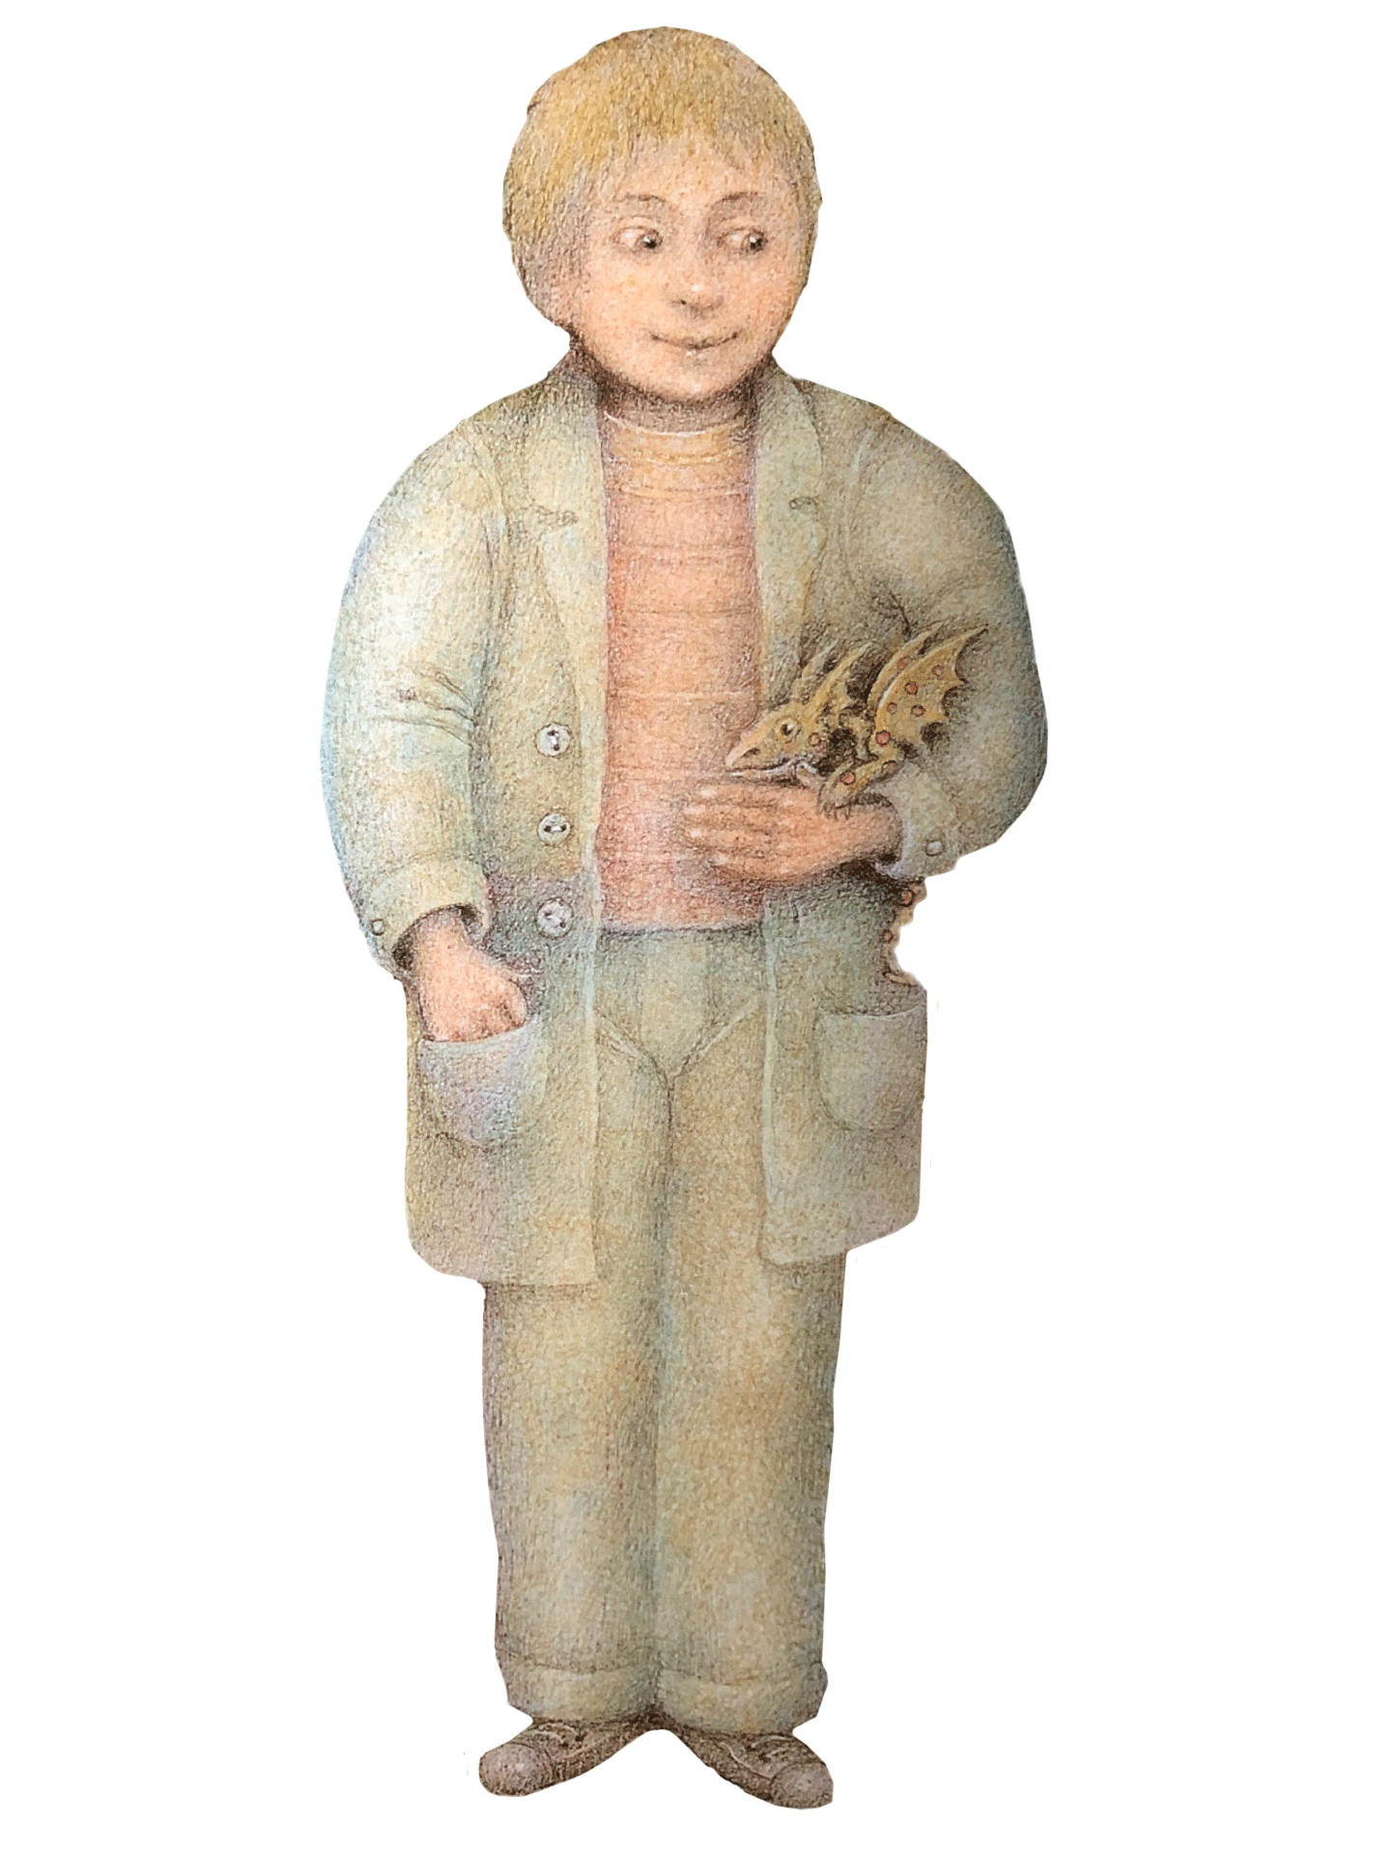

Unit 3 Day 1

The Dragon Machine (Part 1) – Sentences to sequence (5)

Then the trouble began.
George fed the dragons.
George noticed his first dragon on a
wet Thursday.
George found a map that would help.
George started to see lots more dragons.

Unit 3 Day 1

The Dragon Machine (Part 1) – Sentences to sequence (10)

George went to the library for advice.
George started to see lots more dragons.
Dragons were on the telephone wires and amongst the dustbins.
The dragons followed George everywhere.
George found a map of the place where dragons belonged.
Then the trouble began.
George fed the dragons. He gave them delicious stale biscuits and smelly cheese.
George had to clear up after the dragons.
There were dragons in the tulips and teasing
the cat.
George noticed his first dragon on a wet Thursday.

Unit 3 Day 1

The Dragon Machine (Part 1) – Images to Sequence

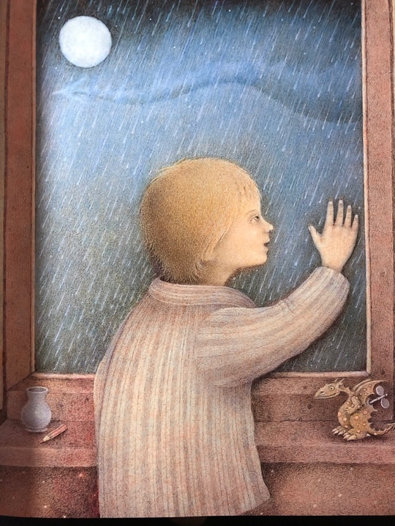 | 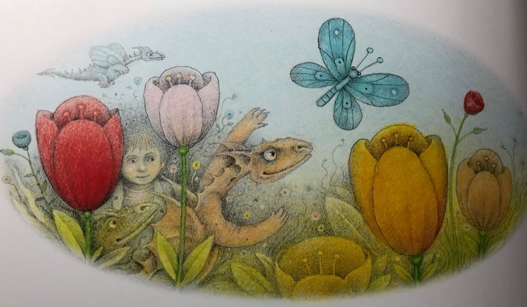
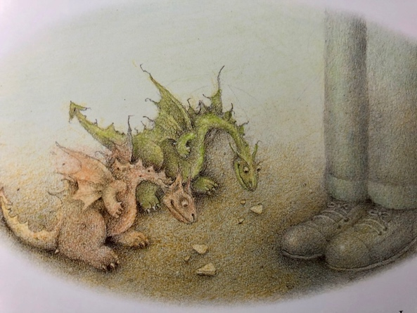 | 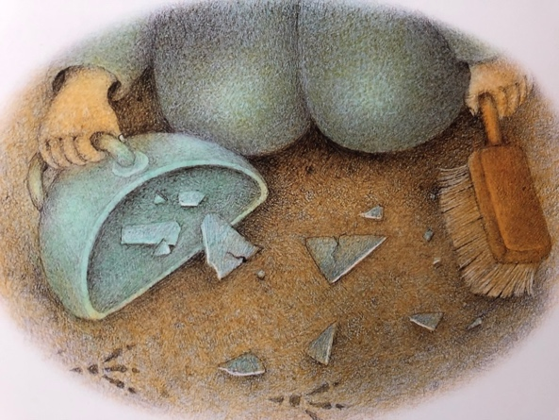
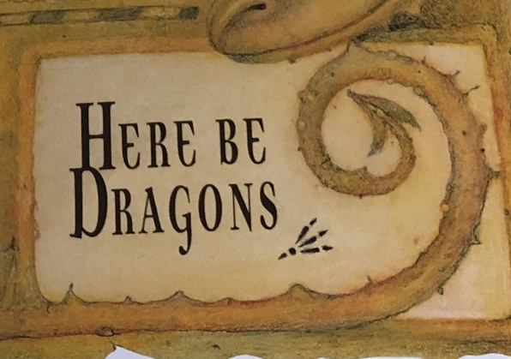

Unit 3 Day 1

Recount Diagram
Events in time order
When?
Where?
What?
Who?
Introduction
Conclusion
What happened in the end?

From Sue Palmer – The Recount Book

Unit 3 Day1

