1. **Choose the correct option.** **[8]**
2. Cell reference is known as the __________.  
   (a) Cell address (b) Cell location  
   (c) Row address (d) None of these
3. A Cell reference is written as _____________  
   (a) Row name + Column name (b) Column name + row name  
   (c) Cell name + column name (d) None of these
4. In the below written formula, identify what is a constant?

  
(a) Length (b) Width   
(c) **+** and **x** (d) None of these

1. Some formulae are already built into a spreadsheet. These are known as __________

(a) Operations (b) Functions   
(c) Argument (d) None of these

1. The average function finds the ________ of all the values in the argument.  
   (a) Sum (b) Mean  
   (c) Difference (d) None of these
2. Select the correct the formula to find the average of below given dataset.

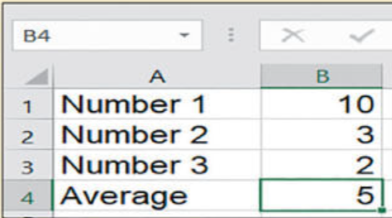

(a) A1+A2+A3/4 (b) = A1+A2+A3/3  
(c) = (B1+B2+B3)/3 (d) None of these

1. Mainly there are _______ data types used in MS Excel.

(a) 1 (b) 2  
(c) 3 (d) 4

1. Data validation is under ______ tab.

(a) File (b) Home  
(c) Data (d) None of these

1. **Ali is working in a supermarket and he is making the spreadsheet where he can find the total and average of the given dataset.**

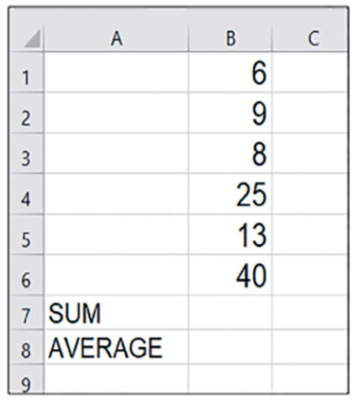

1. Enter the formula in **B7** to calculate the sum of all the numbers, Use the SUM function. **[2]**

Complete the formula = **_________(B1:__)**

1. Enter the formula in **B8** to calculate the average of all the numbers, Use the AVERAGE function. **[2]**

Complete the formula = **_________(B:__)**

1. **Umar is making a user friendly spreadsheet so users can easily enter the required data, however upon applying validation on the given data set the following error appears on the screen.**

**He wants to edit the error message in such a way that user can understand it easily.**

1. What do you think can he edit this error message? **[1]**

____________________________________________________________________

1. If yes then how? What are the steps to edit the error message? **[4]**

____________________________________________________________________

____________________________________________________________________

____________________________________________________________________

____________________________________________________________________

____________________________________________________________________

____________________________________________________________________

1. **Ali is filtering that dataset of traffic violations being held for the past 6 months in Qatar.**

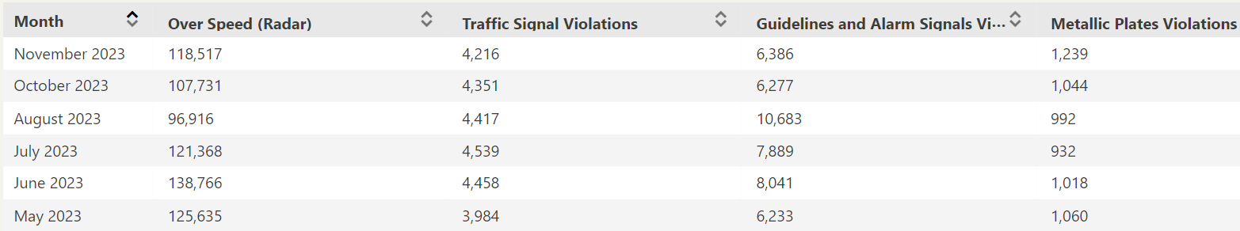

**He is looking forward for your assistance to explain some of the queries related to the given task.**

**First Query**: What is filtration of data means? **[1]**

___________________________________________________________________

___________________________________________________________________

___________________________________________________________________

**Second Query**:

He wants to filter the table that occurred after august.

Can he do that? **[1]**

___________________________________________________________________

If yes then what are the steps that he should follow? And if no then why No? **[3]**

___________________________________________________________________

___________________________________________________________________

___________________________________________________________________

___________________________________________________________________

___________________________________________________________________

___________________________________________________________________

___________________________________________________________________

1. 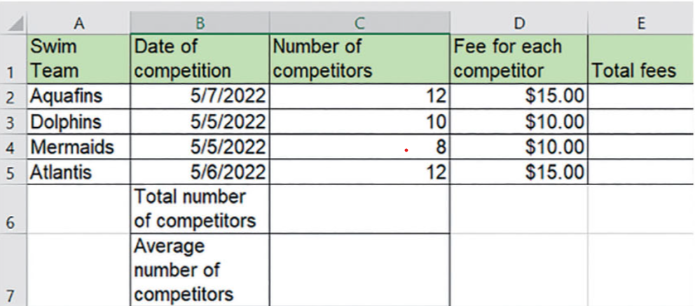**What should be the data type of the values in these fields be? [3]**
2. Swim team
3. Data of Competition
4. Number of competitors