|  |  |  |
| --- | --- | --- |
| Total Marks: 30  Time: 40 Minutes |  | Name: _______________  Date: _______________ |

Task 1:

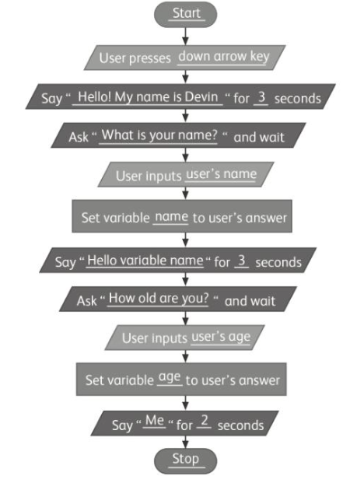

**Task 2:**

