1) Answer the following.

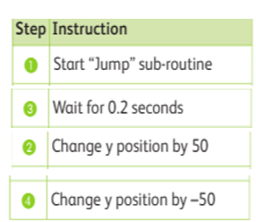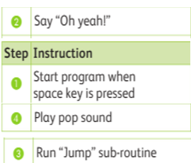 a) Arrange them in the right sequence and explain what are the algorithms are about.

|  |  |
| --- | --- |
|  |  |
|  |  |
|  |  |
|  |  |
|  |  |

|  |  |
| --- | --- |
|  |  |
|  |  |
|  |  |
|  |  |
|  |  |

b. Identify the output for the above algorithm.

________________________________________________________________________

________________________________________________________________________

________________________________________________________________________

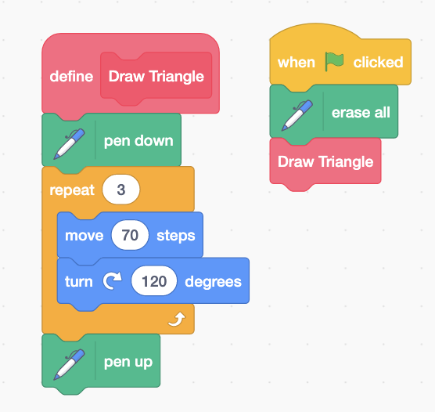c) Write an algorithm for the given Scratch 3 program.

2

1

|  |  |
| --- | --- |
| Steps | Instruction |
| 1 | When _______ clicked |
| 2 | Erase _________ |
| 3 | Sub routine _______ |

Sub-routine “Draw Triangle” To draw Triangle Shape

|  |  |
| --- | --- |
| Steps | Instruction |
| 1 | Define Triangle |
| 2 | Pen _______ |
| 3 | Move _____ steps |
| 4 | Turn ______ degress |
| 5 | Repeat Step ___ ____ times |
| 6 |  |