1) Answer the following.

a) Explain what are the algorithms are about.

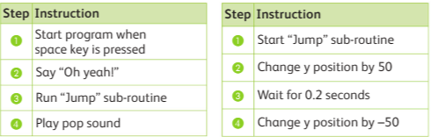

________________________________________________________________________

________________________________________________________________________

________________________________________________________________________

________________________________________________________________________

________________________________________________________________________

________________________________________________________________________

________________________________________________________________________

________________________________________________________________________

________________________________________________________________________

b. Identify the output for the above algorithm.

________________________________________________________________________

________________________________________________________________________

________________________________________________________________________

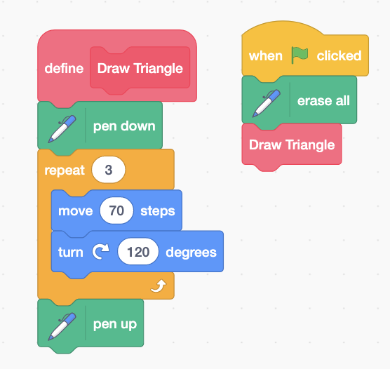c) Write an algorithm for the given Scratch 3 program.

2

1

|  |  |
| --- | --- |
| Steps | Instruction |
|  |  |
|  |  |
|  |  |

Sub-routine “Draw Triangle” To draw Triangle Shape

|  |  |
| --- | --- |
| Steps | Instruction |
|  |  |
|  |  |
|  |  |
|  |  |
|  |  |
|  |  |