Write a recount about Visit to the zoo or A special day. You can use the recount

diagram to help you plan your recount.

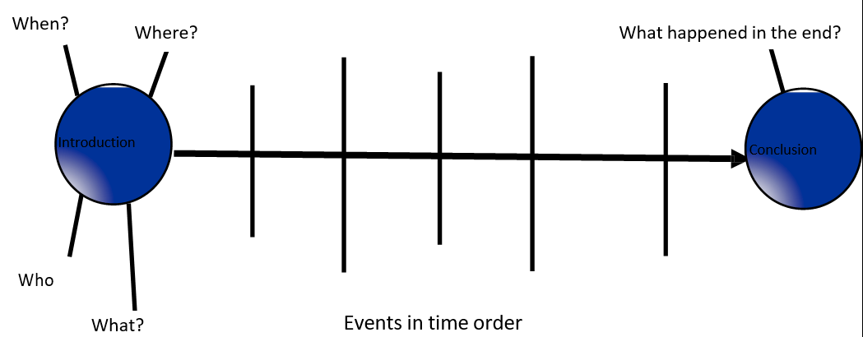**My Recount planner**

## …………………………………………………………………………………………………………………………………………………………………………………………………………………………………………………………………………………………………………………………………………………………………………………………………………………………………………………………………………………………………………………………………………………………………………………….………………………………………………………………………………………………………………………………………………………………………………………………………………………………………………………………………………………………………………………………………………………………………………………………………………………………………………………………

## ……………………………………………………….……………………………………………………………………………………………………………………………………………………………………………………………………………………………………………………………………………………………………………………………………………………………………………………………………………………………………………………………………………………………………………………….……………………………………………………………………………………………………………………………………………………………………………………………………………………………………………………………………………………………………………………………………………………………………………………………………………………………………………………………………………………………………………………….……………………………………………………………………………………………………………………………………………………………………………………………………………………………………………………………………………………………………………………………………………………………………………………………………………………………………………………………………………………………………………………….……………………………………………………………………………………………………………………………………………………………………………………………………………………………………………………………………………………………………………………………………………………………………………………………………………………………………………………………………………………………………………………….……………………………………………………………………………………………………………………………………………………………………………………………………………………………………………………………………………………………………………………………………………………………………………………………………………………………………………………………………………

## …………………………………………………………………………………………………………………………………………………………………………………………………………………………………………………………………………………………………………………………………………………………………………………………………………………………………………………………….…………………………………………………………………………………………………………………………………………………………………………………………………………………………………………………………………………………………………………………………………………………………………………………………………………………………………

|  |  |
| --- | --- |
| I have written my recount using past tense/ past progressive verbs. | 3 |
| I have time connectives in my recount. | 3 |
| My recount has an interesting Beginning middle and an end. | 3 |
| I have used appropriate capital letters and punctuation. | 3 |
| My writing is organised and follows a sequence. | 3 |