1. **Choose the correct answer. /4**
2. When we write an algorithm, we must put the steps in the _______________ order.

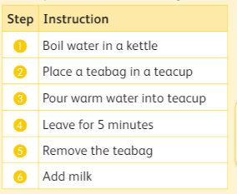

|  |  |
| --- | --- |
| 1. Wrong | 1. Correct |

1. An error or mistake is called a ____________.

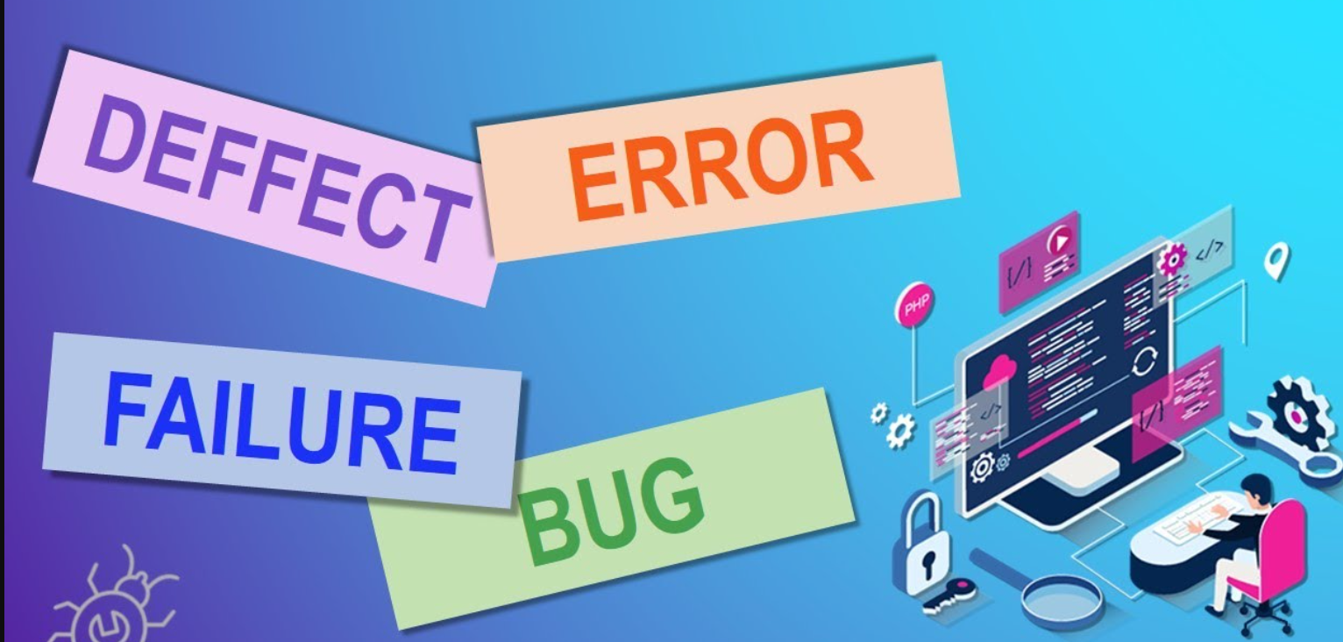

|  |  |
| --- | --- |
| 1. Bug | 1. Event |

1. Sometimes the same instruction happens more than once. We say that this instruction _____________.

 

|  |  |
| --- | --- |
| 1. Repeat | 1. Break |

1. Algorithms that do not work properly contain an ____________.

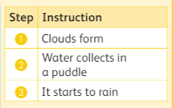 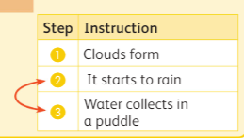

|  |  |
| --- | --- |
| 1. Repeat | 1. Error |

1. **Write the steps in order of the rain collecting in a puddle. /3**

|  |
| --- |
| Water collects in a puddle |
| Clouds form |
| It starts to rain |

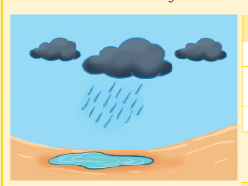

|  |
| --- |
| **Step 1** |
| **Step 2** |
| **Step 3** |

1. **Solve the following puzzle based on the clues given /4**

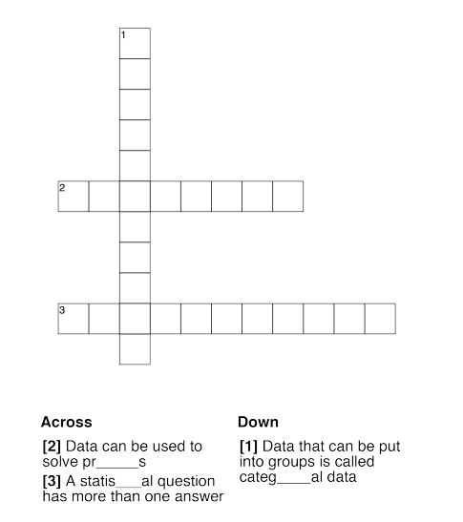

1. **Draw a line to match the data to the labels. /4**

|  |
| --- |
| 1.Rainfall in 3 days: 2mm, 1 mm, 3mm  Rain, Rain, Don't Go Away Rain Gauge - Science Fun |
| 2.Feelings of students: happy, sad |
| 3.Number of students in classes: 25, 30,15 |
| 4. Favourite snack: chips, chocolate, popcorn |

**Numerical data**

**Categorical data**

1. **State the statement is True or False /5**
2. Algorithm that works properly contains an error. ___________
3. A statistical question has only one possible answer. ____________
4. Numerical data can be counted or measured. ____________
5. Data is used to solve problems. ____________
6. Categorical data cannot be grouped into categories. ____________