Question | Description | Marks
1 a | One mark per each correct character in the correct order:  - 9  - 3  - 0  - D | 4
1 b (i) | 00001111 | 1
1 b (ii) | Any one from:  - The value becomes incorrect/inaccurate as the right most bits are lost  - It is divided by 8 | 1
2 (i) | It reduces the file size | 1
2 (ii) | Any four from:  • A compression algorithm is used  • … such as RLE/run length encoding  • Repeating words/characters/phrases are identified // Patterns are identified  • … and indexed  • … with number of occurrences  • … with their position | 4
3 a (i) | The maximum number of FDE cycles/instructions a CPU can  perform/process/execute in a second | 1
3 a (ii) | Increases/improves the performance // Tasks can be performed  quicker/faster  … because more FDE cycles/instructions can be processed in a second | 2
3 b | Stores addresses …  … of next instruction/data to be fetched // where data is to be written to | 2
3 c | Instruction set | 1
4 | Any two from:  − Performs a single/limited/dedicated function/task  − It has a microprocessor  − It has dedicated hardware  − Uses firmware  − It is normally built into a larger device/system  − User normally cannot reprogram  − It does not require much power  − It is cheap to manufacture  − Works automatically // works without human intervention  − It is small (in size)  − It is a real-time system | 2
5 a) | Max three from:  − Solid state drive  − Non-volatile  − Secondary storage  − Flash memory  − Has no mechanical/moving parts  − Uses transistors  − … and cells that are laid out in a grid  − Uses control gates and floating gates  − Can be NAND/NOR (technology)  − Use EEPROM technology  Max two from:  − Stores data by flashing it onto the chips  − Data stored by controlling the flow of electrons through/using transistors/chips/gates  − The electric current reaches the control gate and flows through to the floating gate to be stored  − When data is stored the transistor is converted from 1 to 0 | 4
5 b) | 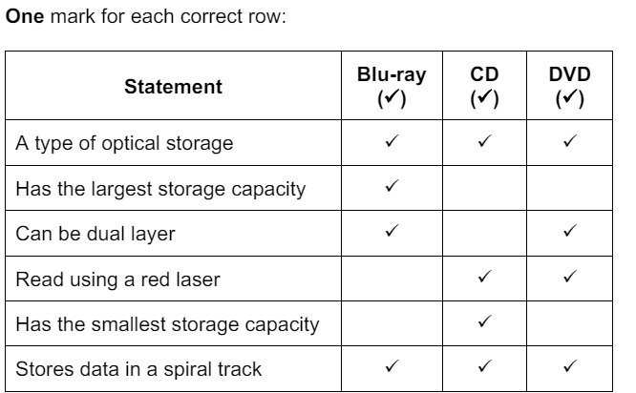 | 6
6 a) | 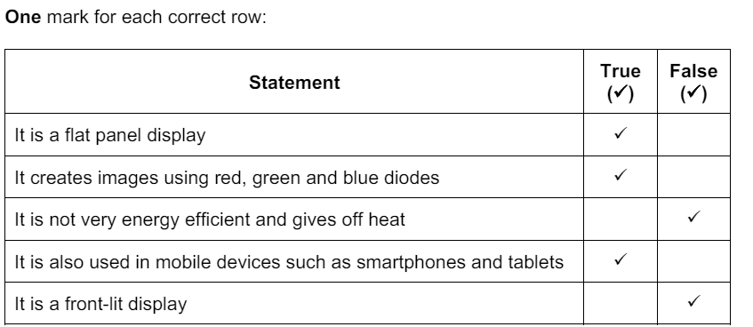 | 5
6 b) | One mark for each correct term in the correct place:  − Control  − Unique  − Identify  − Protocol  − Dynamic | 5
7 | 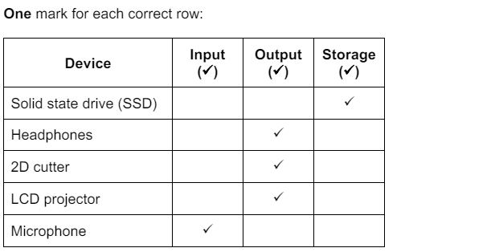 | 5
8 a) | Any three from:  − Liquid crystal display  − The display is made of pixels  − … arranged in a matrix  − Uses a flat panel display  − Backlit display  − … with CCFLs/LEDs  − Uses light-modulating properties of liquid crystals  − Crystals can be turned between opaque and transparent (to allow light to pass)  − Colours created using RGB | 3
8 b) | Any three from:  − Low power consumption  − Runs at cool temperature  − Do not suffer image burn  − Do not suffer flicker issues  − Bright image/colours  − High resolution image  − Cheaper to purchase than e.g. LED screen | 3
9 a) | Any three from:  − Both need a red laser to read/write data  − Both are spun to be read  − Both use spiral tracks for data  − Both are optical storage  − Both are off-line storage // both non-volatile  − Both use pits and lands to store data | 3
9 b) | Any one from:  − DVD can be dual layer, but CD can only be single  − DVD has higher storage capacity  − DVD has a shorter wavelength laser  − DVD are spun faster  − DVDs have a higher data transfer rate | 1
10 | 1 mark for each correct answer:  PC  keeps track of the memory address of the next instruction to be executed in a program  Program Counter  CIR  holds the current instruction so that it can be decoded and input to the control and timing unit  Current Instruction register. | 2
11 | One mark per mark point, max three  MP1 variables and constants should have meaningful identifiers  MP2 …so that programmers/future programmers are able to understand  their purpose  MP3 they are both used for data storage  MP4 constants store values that never change during the execution of a  program // by example  MP5 variables contain values that have been calculated within the  program / can change during the execution of the program // by  example | 3
12 | 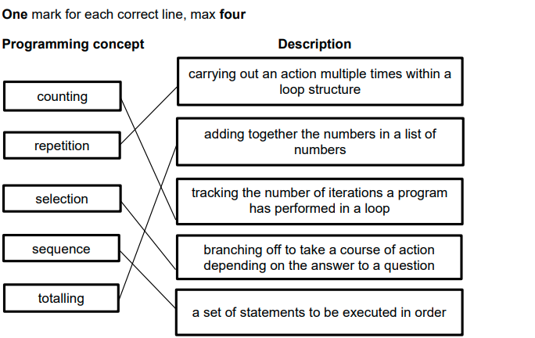 | 4
13 a | DECLARE sum, number : Integer  sum <- 0  number <- 1  WHILE number <= 10 DO  Sum <- Sum + Number  number <- number + 1  OUTPUT "The sum of the first 10 number is:" , Sum | 5
13 b | Start  Sum <- 0  num <- 0  Is num <= 10  false  True  Sum <- sum + num  num <- num + 1  End | 5
14 | One mark for any two correct lines  DECLARE P : STRING  P <- "The world"  DECLARE Q : CHAR  Q <- 'W' | 2

