

TERM II

EXAMINATIONS

REVISION TEST

2023-2024

Key Stage 3 (Year VIII____)

Date :

Name of the Candidate : _________________________________________________________

Subject : COMPUTER SCIENCE

Maximum Marks : 75

Instructions to the candidate:

* The Exam is for 1 hour 30 minutes.
* Read the instructions carefully.
* Please make sure you have all the stationery items.
* Write in dark blue or black pen.
* You may use a soft pencil for any diagrams, graphs or rough work.
* Do not use staples, paper clips, highlighters, glue or correction fluid.
* No marks will be awarded for using the brand names of software packages or hardware.
* Answer all questions.
* At the end of the examination, fasten all your work securely together.
* The number of marks is given in brackets [ ] at the end of each question or part question.

|  |  |  |
| --- | --- | --- |
|  | **Maximum Marks** | **Marks Obtained** |
| **TOTAL** | **75** |  |

Checked by : ____________________________

Rechecked by : ____________________________

1. Binary numbers can be converted to hexadecimal.

(a) Convert the two binary numbers to hexadecimal.

10010011 ..........................................................................................................

00001101 ..........................................................................................................

[4]

Working space

.........................................................................................................................

.........................................................................................................................

.........................................................................................................................

.........................................................................................................................

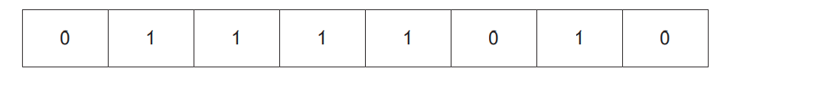(b) A value is stored as a binary number in a register

A logical right shift of three places is performed on the binary number.

(i) Complete the binary register to show its contents after this logical right shift.

[1]

(ii) State one effect this logical shift has on the binary number.

.........................................................................................................................

......................................................................................................................... [1]

1. Text that is input into a computer can be stored in a text file.

A text file can be compressed using lossless compression.

(i) State what effect this has on the file size.

...........................................................................................................................

...........................................................................................................................

[1]

(ii) Describe how lossless compression compresses the text file.

...........................................................................................................................

...........................................................................................................................

...........................................................................................................................

...........................................................................................................................

...........................................................................................................................

...........................................................................................................................

...........................................................................................................................

[4]

1. A user’s computer has a central processing unit (CPU) that has a clock speed of 2GHz.

She wants to change it to a CPU that has a clock speed of 3GHz.

(a) (i) State what is meant by clock speed.

................................................................................................................

................................................................................................................ [1]

(ii) Explain the effect this change will have on the performance of the CPU.

................................................................................................................

.................................................................................................................

................................................................................................................ [2]

(b) The CPU contains a memory address register (MAR).

Describe the role of the MAR in the fetch–decode–execute cycle.

...................................................................................................................

................................................................................................................... ...................................................................................................................

................................................................................................................... [2]

(c) The CPU has a list of all the machine code commands it can process.

State the name of this list of commands.

................................................................................................................... [1]

1. A washing machine is an example of an embedded system.

Give two characteristics of an embedded system.

1 ..........................................................................................................................

..........................................................................................................................

2 ..........................................................................................................................

..........................................................................................................................

[2]

1. a) Alessandro has some important data stored on his computer.

Alessandro uses an SSD to store his data.

Describe what is meant by an SSD and how it operates to store data.

...................................................................................................................

...................................................................................................................

...................................................................................................................

...................................................................................................................

...................................................................................................................

...................................................................................................................

[4]

b) Alessandro also uses off-line storage to store his data.

Three examples of off-line storage are Blu-ray, CD and DVD.

Six statements are given about off-line storage.

Tick (✓) to show if each statement applies to Blu-ray, CD, or DVD.

Some statements apply to more than one example of off-line storage.

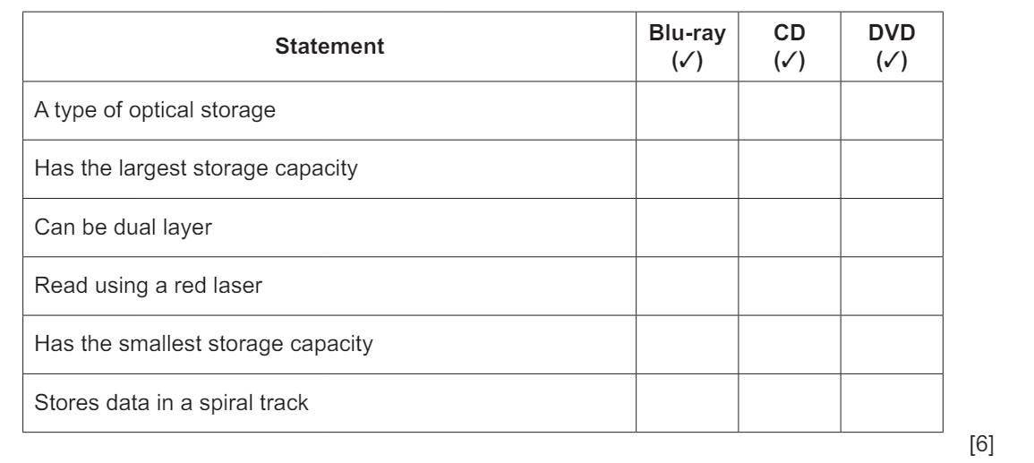

1. Tammy is buying a new computer that has an LED display.

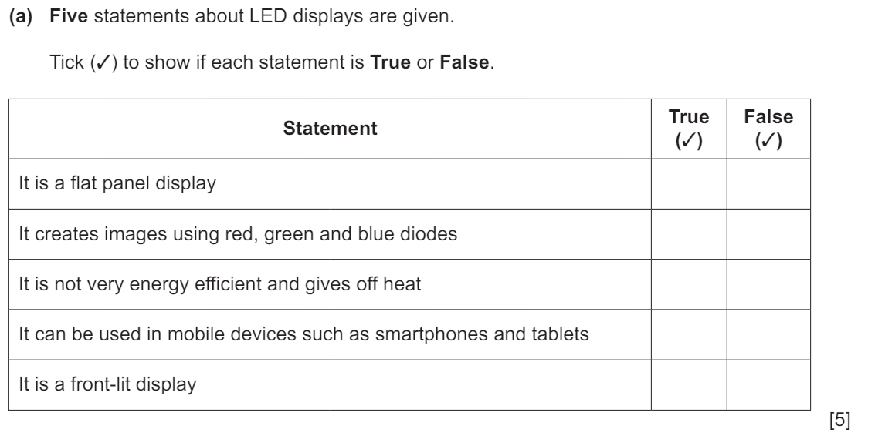

1. Edith is buying a new computer monitor that displays images using LCD technology.

1. Elle uses both CDs and DVDs to store her school projects.

1. Define the role of following registers
2. PC

......................................................................................................................

......................................................................................................................

1. CIR

.....................................................................................................................

......................................................................................................................

[2]

1. Explain how variables and constants should be used when creating and running a program.

............................................................................................................................

............................................................................................................................

............................................................................................................................

............................................................................................................................

............................................................................................................................

............................................................................................................................

[3]

1. A screenshot of a computer

   Description automatically generatedDraw a line to connect each programming concept to the most appropriate description.

[4]

1. A program is required to add first ten natural numbers:
2. Write a pseudocode to find the sum of first ten natural numbers (1 – 10) using WHILE DO ENDWHILE loop.

Pseudocode

......................................................................................................................

......................................................................................................................

......................................................................................................................

......................................................................................................................

......................................................................................................................

......................................................................................................................

[5]

b) Draw a flowchart for the program in part (a)

Flowchart:

[5]

1. The variables P and Q are used to store data in a program. P stores a string. Q stores a character.

Write pseudocode statements to declare the variables P and Q, store "The world" in P and store 'W' in Q.

..........................................................................................................................

.........................................................................................................................

.........................................................................................................................

........................................................................................................................

........................................................................................................................

........................................................................................................................

[2]