Types of Organisation
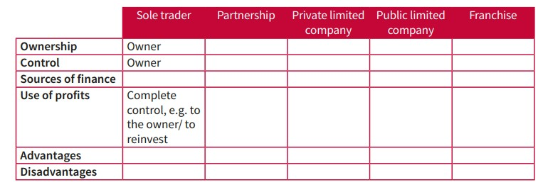
- Find out the information required to complete the table below. Use the space below to add advantages and disadvantages separately for each organisation.

……………………………………………………………………………………………………………………………………………………………………………………………………………………………………………………………………………………………………………………………………………………………………………………………………………………………………………………………………………………………………………………………………………………………………………………………………………………………………………………………………………………………………………………………………………………………………………………………………………………………………………………………………………………………………………………………………………………………………………………………………………………………………………………………………………………………………………………………………………………………………………………………………………………………………………………………………………………………………………………………………………………………………………………………………………………………………………………………………………………………………………………………………………………………………………………………………………………………………………………………………………………………………………………………………………………………………………………………………………………………………………………………………………………………………………………………………………………………………………………………………………………………………………………………………………………………………………………………………………………………………………………………………………………………………………………………………………………………………………………………………………………………………………………………………………………………………………………………………………………………………………………………………………………………………………………………………………………………………………………………………………………………………………………………………………………………………………………………………………………………………………………………………………………………………………………………………………………………………………………………………………………………………………………………………………………………………………………………………………………………………………………………………………………………………………………………………………………………………………………………………………………………………………………………………………………………………………………………………………………………………………………………………………………………………………………………………………………………………………………………………………………………………………………………………………………………………………………………………………………………………………………………………………………………………………………………………………………………………………………………………………………………………………………………………………………………………………………………………………………………………………………………………………………………………………………………………………………………………………………………………………………………………………………………………………………………………………………………………………………………………………………………………………………………………………………………………………………………………………………………………………………………………………………………………………………………………………………………………………………………………………………………………………………………………………………………………………………………………………………………………………………………………………………………………………………………………………………………………………………………………………………………………………………………………………………………………………………………………………………………………………………………………………………………………………………………………………………………………………………………………………………………………………………………………………………………………………………………………………………………………………………………………………………………………………………………………………………………………………………………………………………………………………………………………………………………………………………………………………………………………………………………………………………………………………………………………………………………………………………………………………………………………………………………………………………………………………………………………………………………………………………………………………………………………………………………………………………………………………………………………………………………………………………………………………………………………………………………………………………………………………………………………………………………………………………………………………………………………………………………………………………………………………………………………………………………………………………………………………………………………………………………………………………………………………………………………………………………………………………………………………………………………………………………………………………………………………………………………………………………

