1. Solve the equations
$6=3\sqrt{x}-1.5$

$x^{2}-24=120$

2. For each equation, complete the table of values and draw its graph for values of x from −1 to 3.

y = 2x – 3

|  |  |  |  |  |  |
| --- | --- | --- | --- | --- | --- |
| X | -1 | 0 | 1 | 2 | 3 |
| y |  |  |  |  |  |

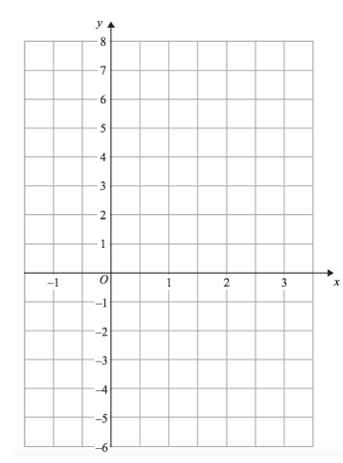

1. Evaluate the following

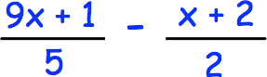

2. 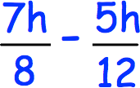
3. 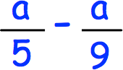
4. Accurately draw the following triangles

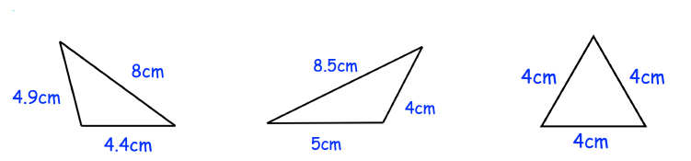

1. Accurately draw an isosceles triangle with an angle of 50°
2. Matthew says 9 + 3 x 2 = 15. Is he correct?
3. Work out

(a) 5 x 3 + 2 x 6

(b) 9 ÷ 3 + 15 x 2

(c) 10 ÷ 2 − 2 x 1

(d) 5 x (2 + 1) + 4

(e) 8 + (5 − 1) x 3

(f) 50 − (1 + 4) x 4

1. Here is a list of fractions.

$\frac{15}{20}$ $\frac{33}{44}$ $\frac{12}{16}$ $\frac{26}{32}$ $\frac{21}{28}$

One of these fractions is not equivalent to $\frac{3}{4}$.

Write down the fraction.

1. Calculate the following, give your answers as a mixed number in their simplest form.



$2\frac{1}{5}+1\frac{1}{7}=$

$2\frac{1}{5}-1\frac{1}{7}=$

$1\frac{3}{4} × 1\frac{1}{2}=$

$1\frac{1}{6}÷\frac{2}{3}=$

6. Calculate the following, give your answers in their simplest form.




$1-\frac{1}{3}=$

$\frac{1}{10}+\frac{3}{5}=$

$\frac{2}{3}-\frac{1}{4}=$

$\frac{3}{4}×\frac{4}{9}=$

$\frac{3}{5}÷\frac{3}{8}=$

12. Find $\frac{2}{7}$ of 210
13. $\frac{3}{7}$ of a number is 15. What is the number?
14. Below are examples of common mistakes people make when rounding to a given significant figure. In each example spot the mistake, explain why it is wrong and what the correct answer should be.  
      
    *Round the following to 3 significant figures.*

|  |  |  |
| --- | --- | --- |
| $8,005,246$ | $0.995$ | $4.8$ |
| $=8,005,000$ | $=0.100$ | $=5.00$ |

1. Expand and simplify these expressions
2. a(3b – 4) + b(2a + 6)
3. x(4x + 3) - 4x(x - 3)
4. x(2x + 3) – 4(3x – 1)
5. 3(2e + f) + 2(e – 2f)
6. (g – h) – 4(g + 2h)
7. Solve the following equations
8.       
9.       
10. Shown is an isosceles triangle
11. Explain why 4x + 15 = 33 − 2x
12. Find x
13. Find the perimeter of the isosceles triangle

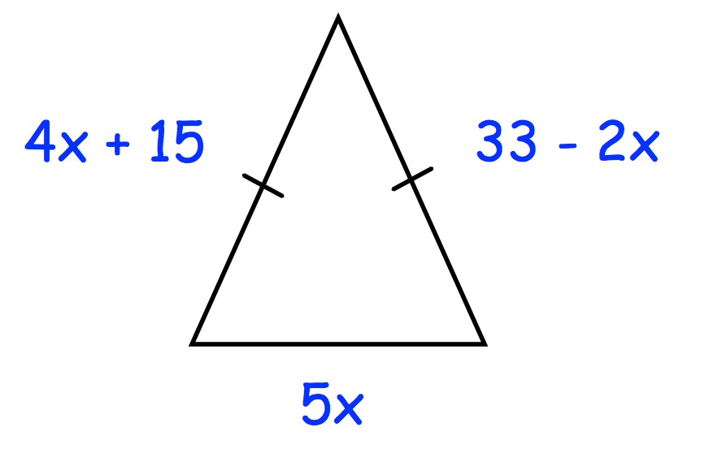

1. Toby has completed his homework. Can you spot any mistakes?

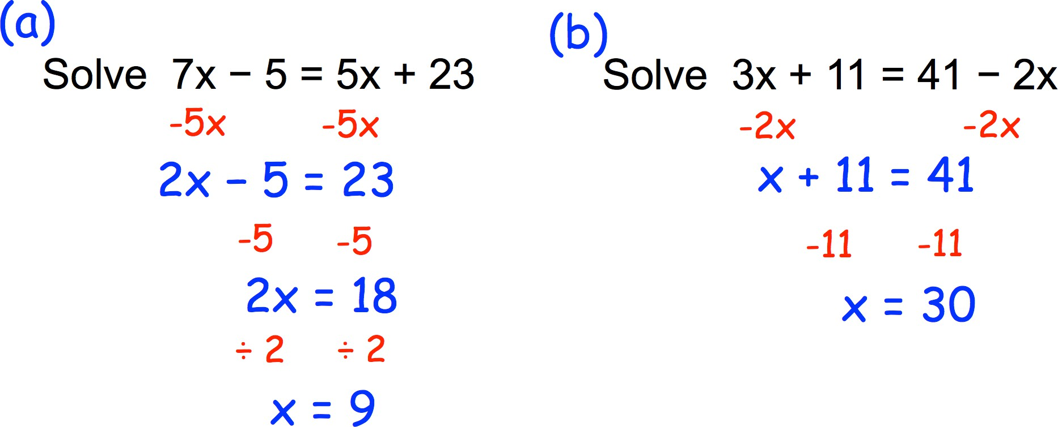

1. Find the size of each angle

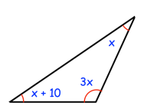

1. Show the sum of angles x and y is always equal to angle z

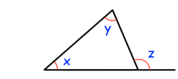

1. Four of the angles of a pentagon are 97°, 114°, 127° and 84°. Work out the size of the fifth angle.
2. Find the size of each missing angle.

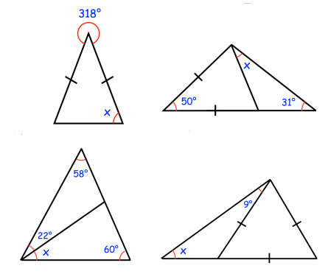

1. Find the value of $x$ in each diagram.

$$4x$$

$$3x$$

$$2x$$

(a) (b) (c)

$$3x$$

$$3x+10°$$

$$2x-35°$$

$$2x$$

d)

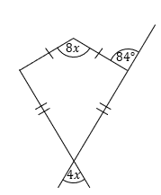

1. Workout the missing angle

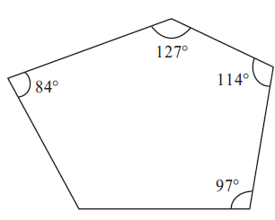

1. A regular polygon has an exterior angle of 30°. Work out the number of sides of the polygon.
2. The diagram shows a regular polygon with 7 sides. Work out the value of *x*.

Give your answer correct to 1 decimal place.

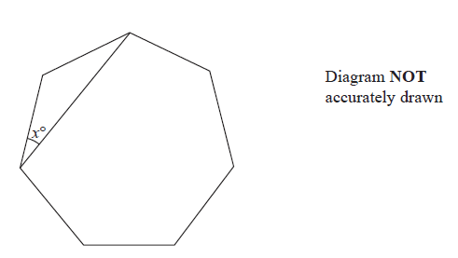

1. The size of each exterior angle of a regular polygon is 18°.

(a) Work out how many sides the polygon has.

(b) Work out the **sum** of the interior angles of the polygon

1. The diagram shows part of a tiling pattern. The tiling pattern is made from three shapes. Two of the shapes are squares and regular hexagons. The third shape is a regular *n*-sided polygon **A**. Work out the value of *n*.

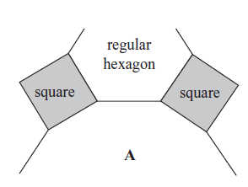

1. Shown below are the graphs of *y* = − *x* + 4 and *y* = *x* – 2

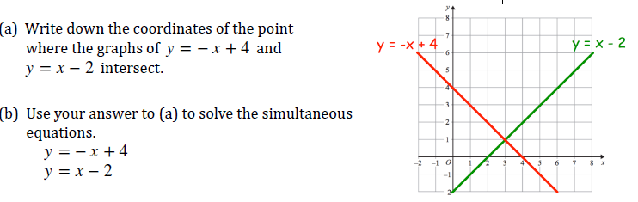

1. By drawing the graphs of *y* = 3*x* + 1 and *x* + *y* =7 Solve the simultaneous equations

*y* = 3*x* + 1

*x* + *y* =7

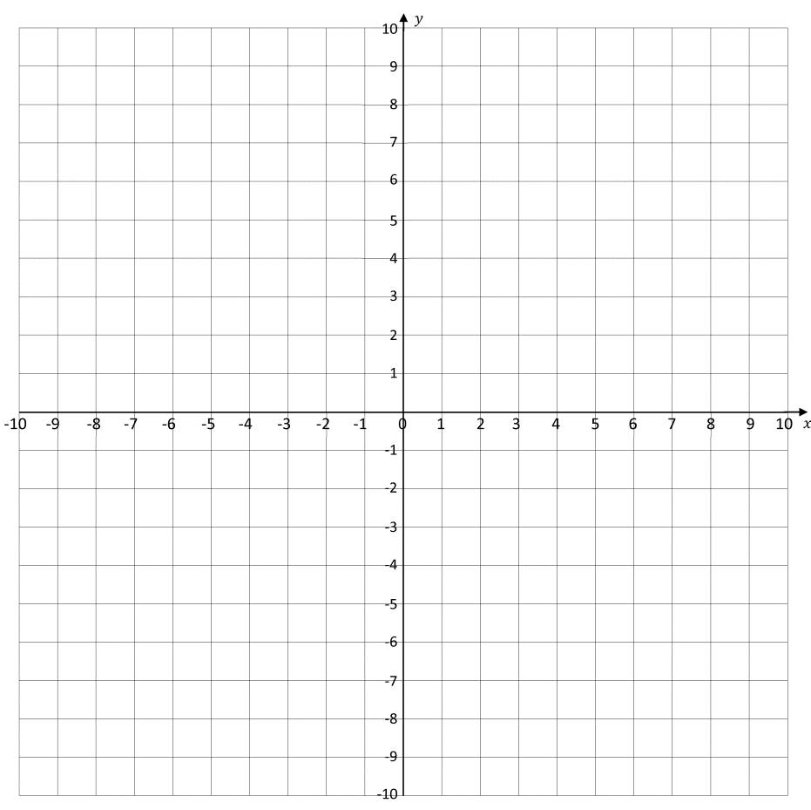

1. Find the gradient of each of these lines

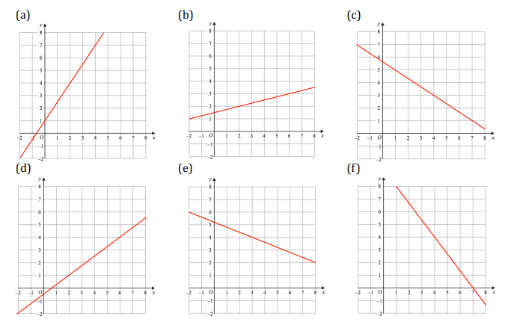

1. Find the value of w, x and y

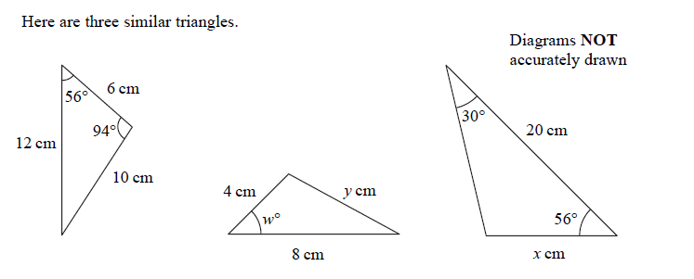

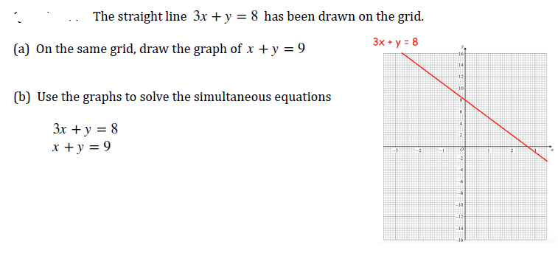

1. A is the point with coordinates (1, 4). B is the point with coordinates (7, 22). Find the gradient of AB.
2. The line passing through (4, a) and (8, 1) has gradient ¾. Work out the value of a.
3. Write down the equation of the lines below

(a) gradient of 3 and y−intercept of 6

(b) gradient of 2 and y−intercept of −1

(c) gradient of −4 and y−intercept of 3

(d) gradient of 8 and y−intercept of 4

(e) gradient of 1 and passing though (0, 4)

(f) passing through (0, −2) with gradient 4

1. Do the lines y = 3x + 1 and 4x − 2y + 3 = 0 have the same gradients?
2. A straight-line L passes through the points (0, 6) and (4, −2). A straight-line M passes through the point (0, 1) and is parallel to line L. Find the equation of the line M
3. The two triangles shown are similar. Find the missing length $y$.

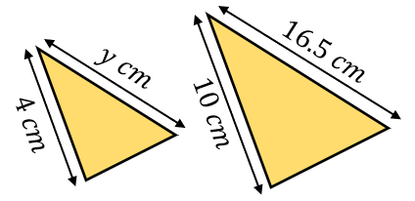

Triangles $A$ and $B$ are similar. Find the missing length $x$.

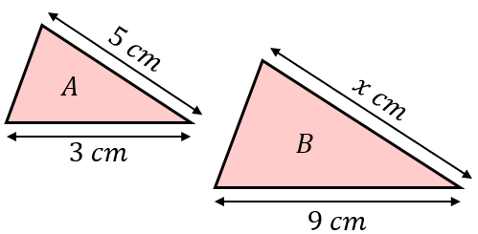

1. Construct the perpendicular bisector of the line XY.

$$Y$$

$$X$$

1. Construct the bisector of the angle BAC.

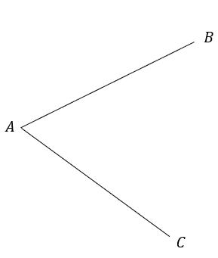

1. Using a protractor, draw an angle of 120o. Using a compass and ruler only, construct its angle bisector. Check your answer by measuring the two angles formed.
2. Use a ruler, protractor and compasses to construct the triangle ABC.
3. Construct a line that is perpendicular to AB and passes through C.
4. Calculate the area of the triangle to the nearest cm2.

