Unit 1: Making programs clear Worksheet 5

Resetting objects
Name: Draw lines to match the block code to its action.


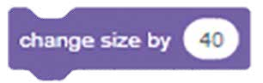
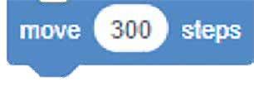
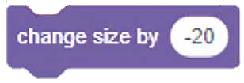

resets an object’s position
moves object to the right of the screen
makes object’s size smaller
makes object size larger
resets an object to original size

Cambridge Primary Computing Stage 3 © Hodder & Stoughton Limited 2023

