1. An experiment was carried out using the apparatus shown.

The carbon dioxide content of the water in each test-tube was measured at the start and again three hours later.

In which test-tube would there be a decrease in carbon dioxide content?

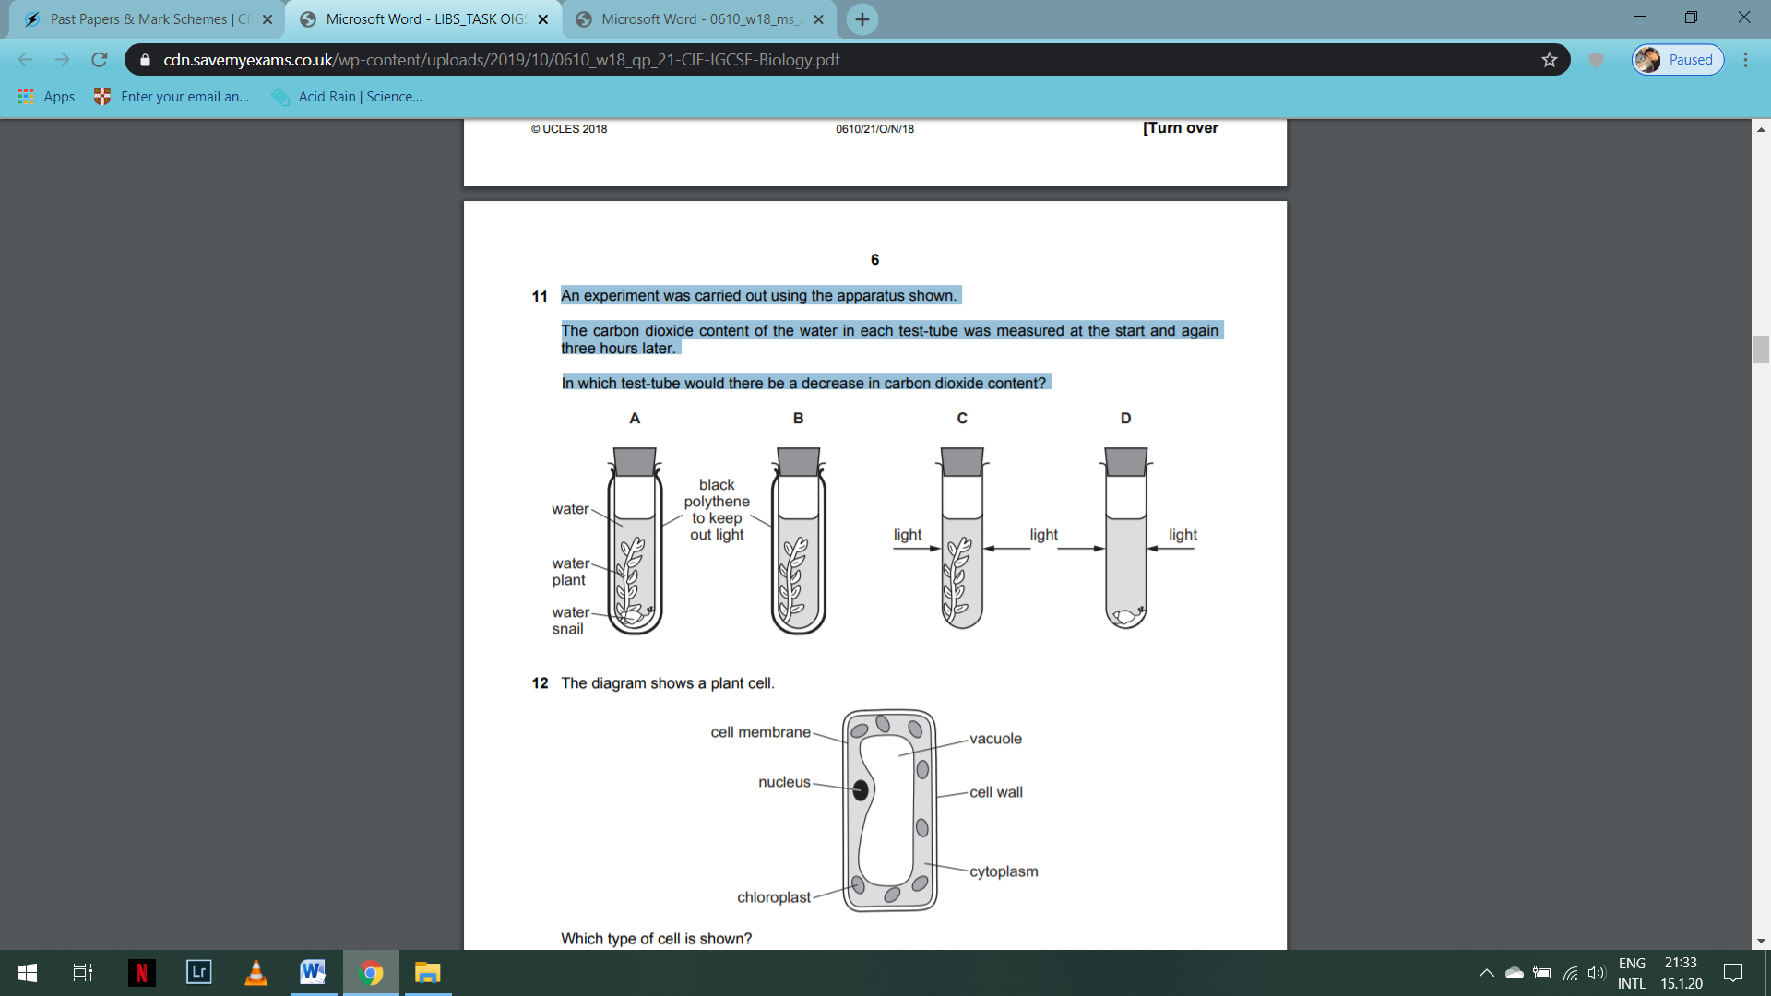

1. The diagram shows a plant cell.

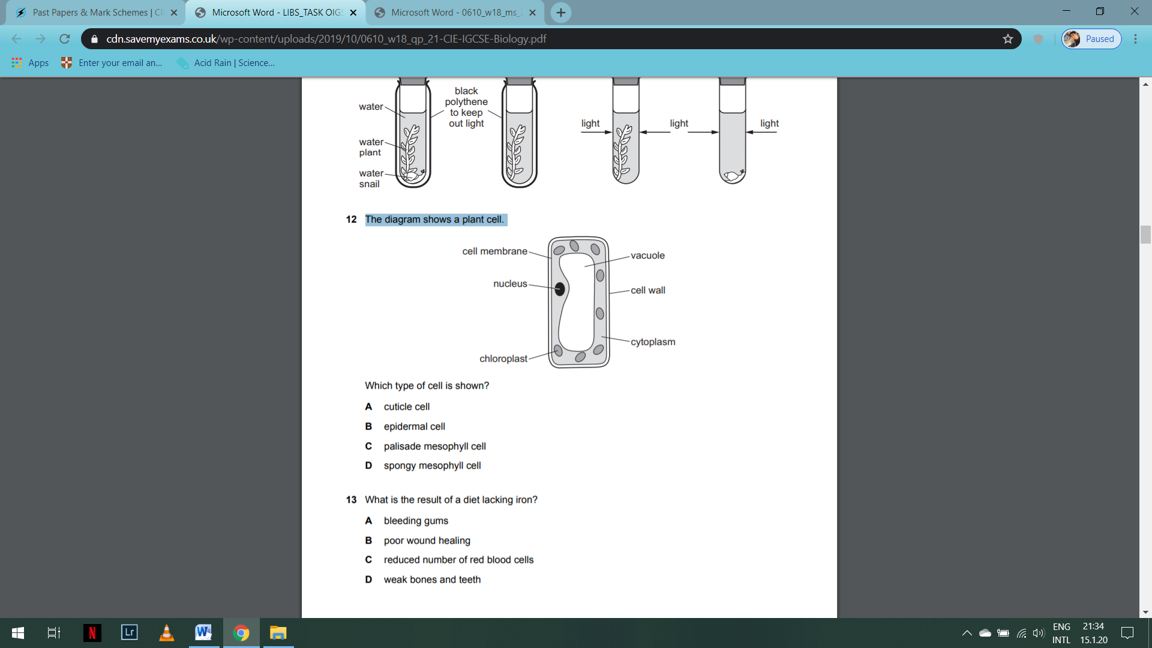

Which type of cell is shown?

**A** cuticle cell

**B** epidermal cell

**C** palisade mesophyll cell

**D** spongy mesophyll cell

1. The photomicrograph shows a cross-section through a buttercup root.

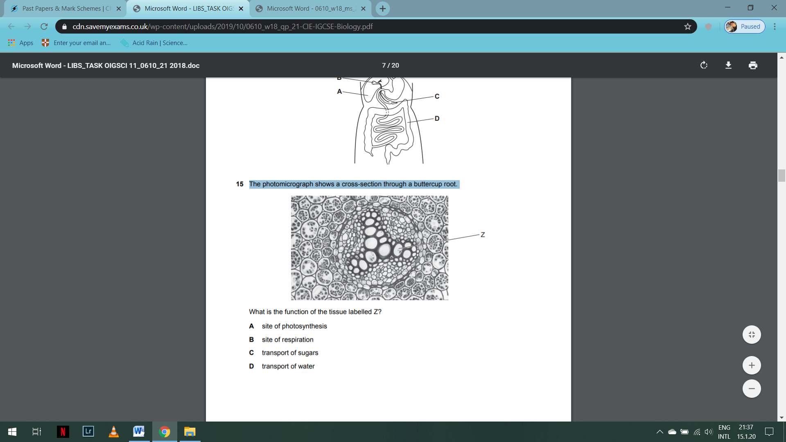

What is the function of the tissue labelled Z?

**A** site of photosynthesis

**B** site of respiration

**C** transport of sugars

**D** transport of water

1. Roots and leaves both act as a source and a sink for sucrose and amino acids at different times during the year.

At which point in the year are the roots most active as a source?

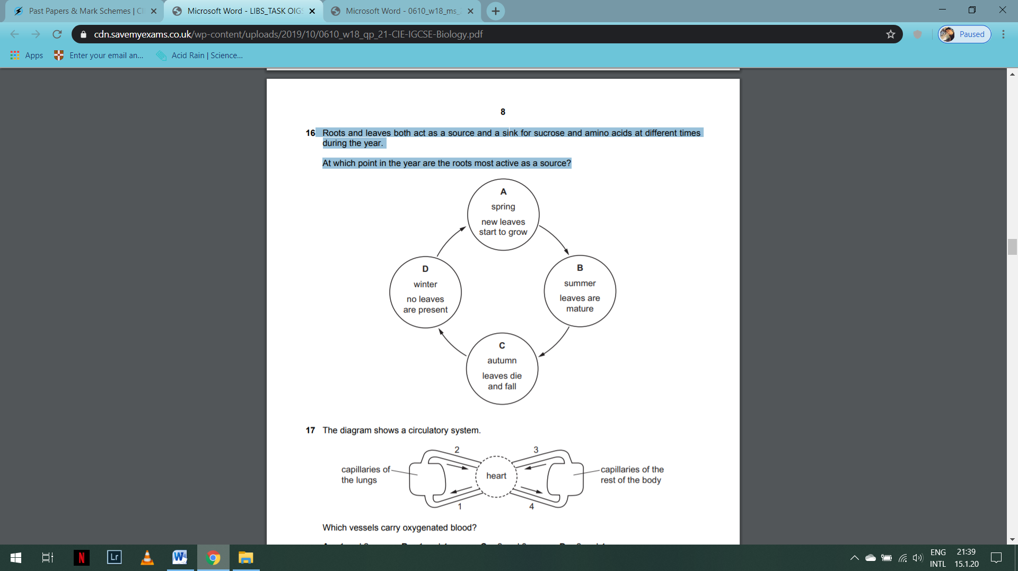

1. Mineral ions are needed for plant growth.

Complete Table 5.1 to show the function and effect of the lack of some mineral ions on plants.

One has been done for you.

|  |  |  |
| --- | --- | --- |
| mineral ion | function in plants | effect of lack of mineral ion on plants |
| nitrate |  |  |
| magnesium |  |  |
| phosphate | used for making DNA | poor root growth |

[4]