Environment | Characteristic of the environment
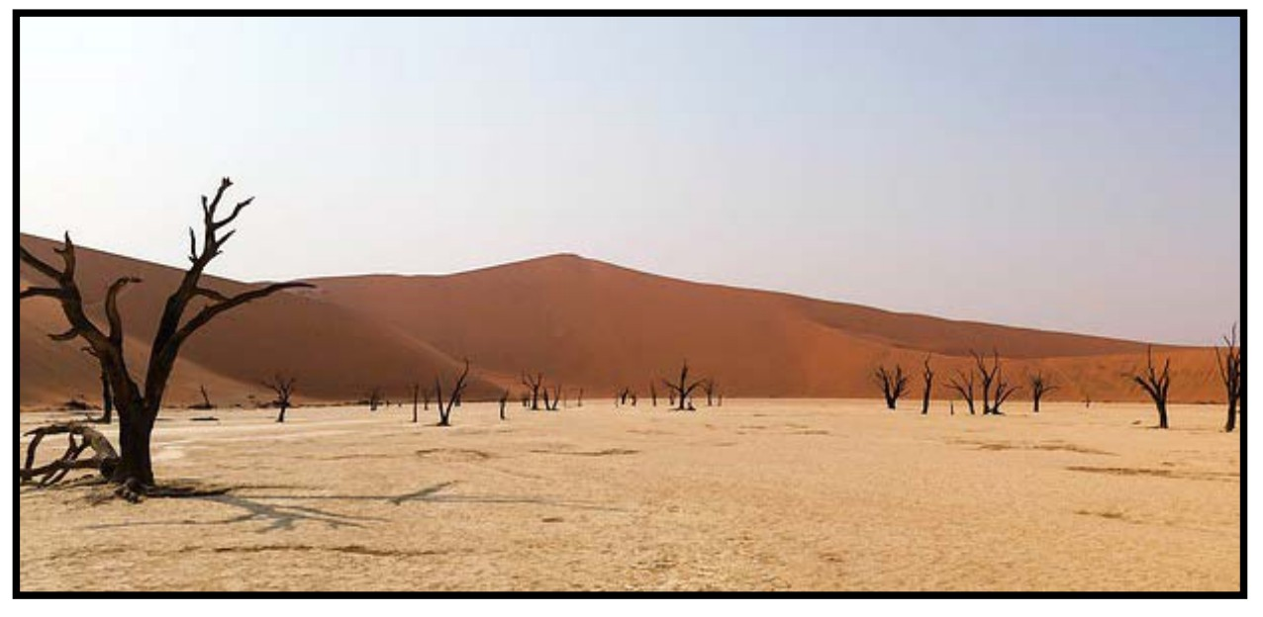 | This is a desert environment. Water is scarce, as is food. Temperatures reach over 50⁰C during the day and drop to 0⁰C at night. The ground lacks nutrients and is unstable. Major predators include large scorpions, poisonous snakes and a form of desert lion.
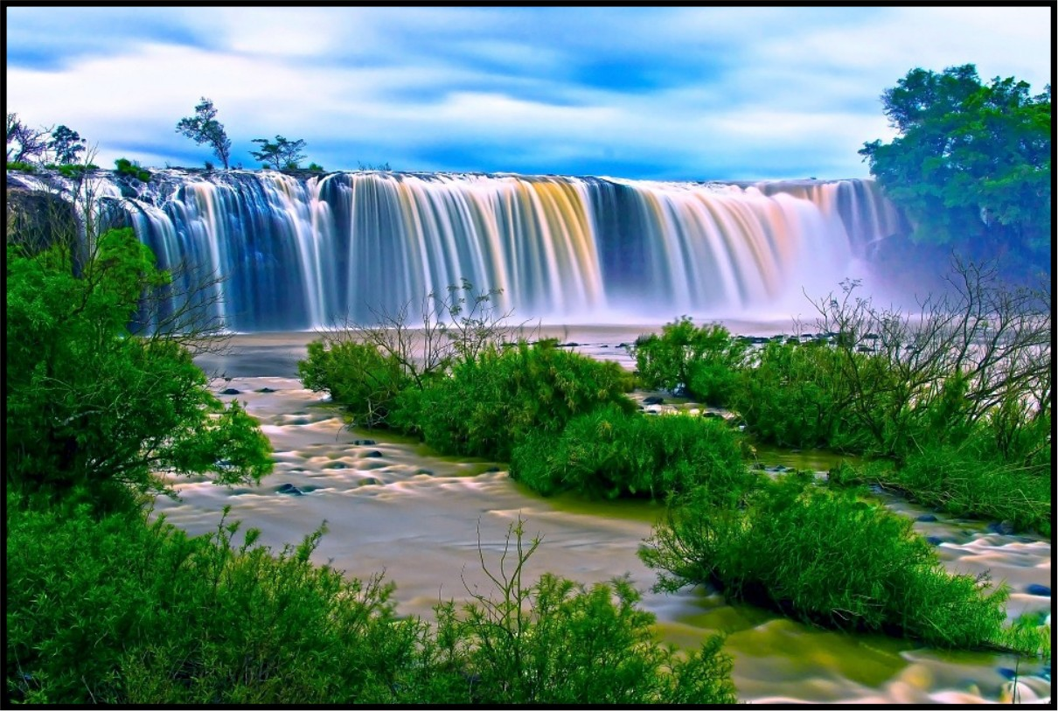 | This is a watery environment. Solid land that doesn’t flood is scarce, but food is abundant in the form of fish and vegetation. Temperatures remain fairly constant at a comfortable  18-20⁰C. Major predators include a small species of shark, bears and boa constrictors. There are also small poisonous frogs and highly toxic tarantulas. Watch out for the lethal shrubs that contain paralysing toxins when eaten.
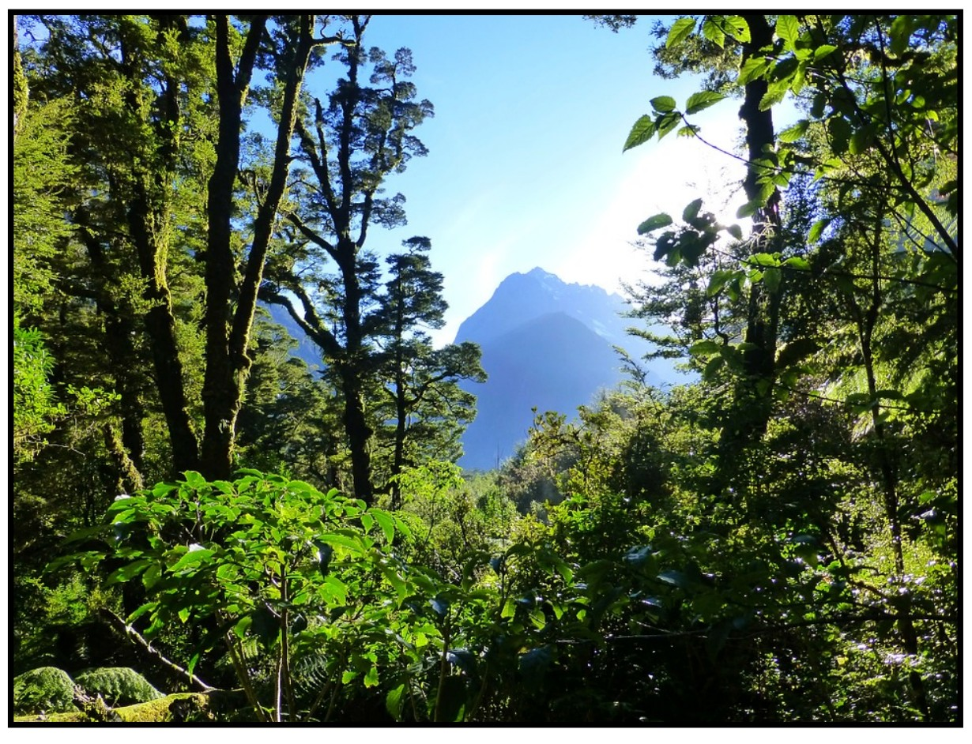 | This is a lush forest environment. Water is plentiful, as is food. Temperatures reach 25⁰C during the day and drop to 10⁰C at night. Major predators include large wolves and leopards as well as a large eagle species that hunts in packs! There are many poisonous berries in this woodland and trees are susceptible to canker diseases.
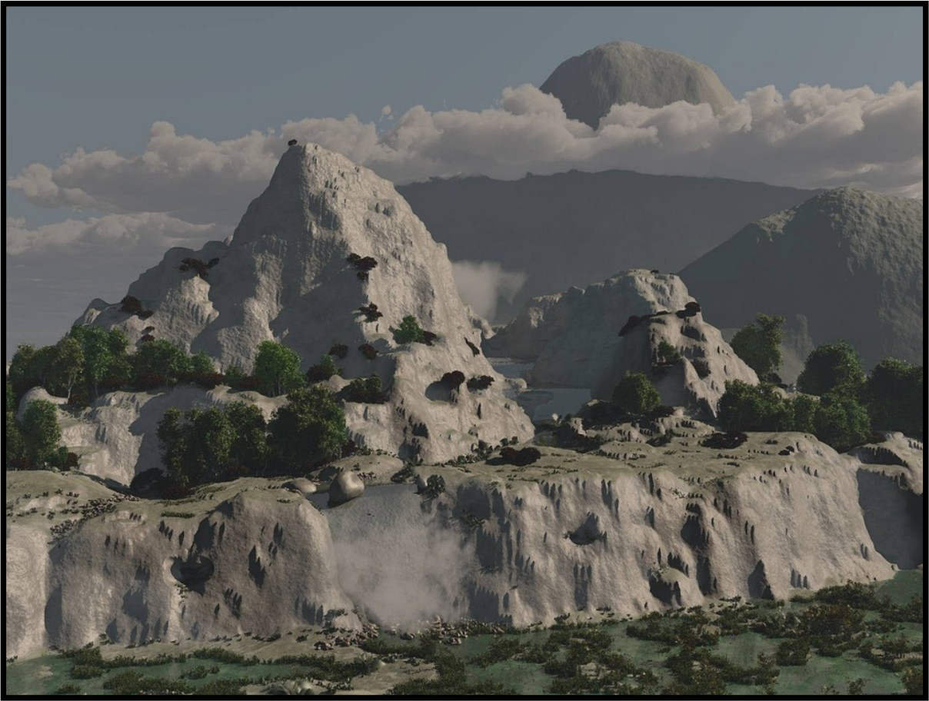 | This is a mountain and plateau environment. Water is available from the many streams and rivers running off the mountains, and while food is available, many plants are spikey and tricky to eat. Temperatures range from 12-22⁰C during the day and can drop to below 0⁰C at night. The terrain is steep and rocky and plants can sometimes struggle to put down deep roots. Shelter can be limited. Major predators include mountain lions, hawks and foxes. There is an abundance of insect life which sustains a range of small omnivorous mammals.

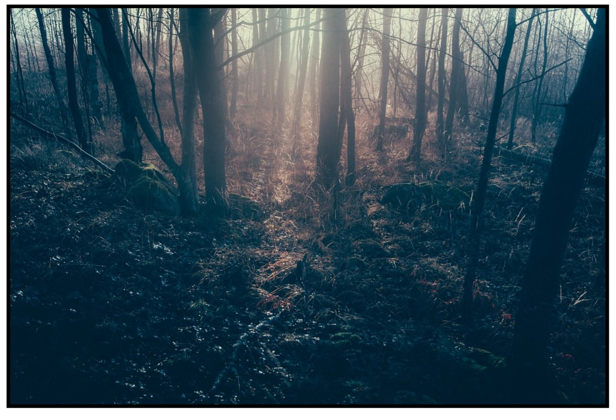 | This is a dark and dense forest environment. Water is plentiful and the general atmosphere is damp. Fungus and plants that require a low level of sunlight thrive, as do insects. This provides food for an array of small omnivorous mammals. Temperatures remain around 18⁰C during the day and night. The forest is awash with poisonous plants, insects and snakes, with major predators including wild dogs, mid-sized wild cats and bears. Vision within the forest is limited due to the low light levels.
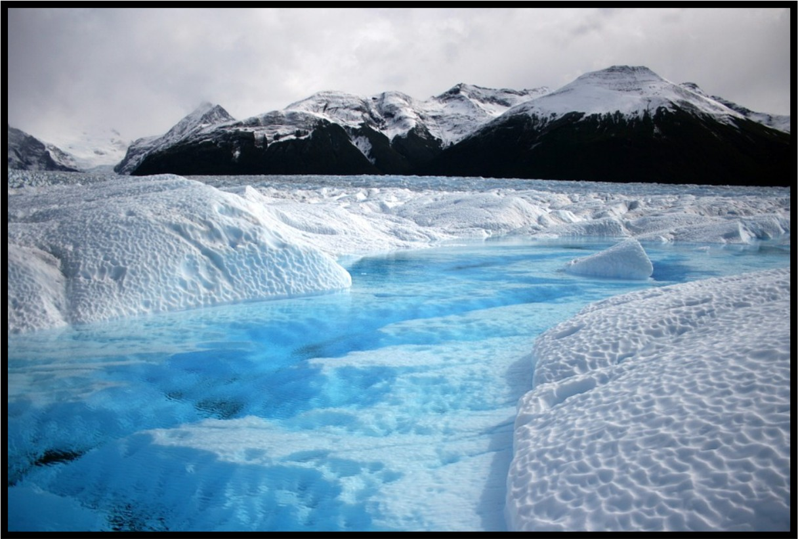 | This is an icy and snowy environment. Water is locked up in the ice and food is scarce.  Temperatures never reach higher than a few degrees C during the day and can drop to -40⁰C at night. Plant life is very limited as are insects. Fish is abundant in floes. Major predators include snow bears and foxes. This land is very white.

