**Science - Year 4**

**Living Things & their Habitats – Block 4LvH2**

**Help Our Habitats!**

**Session 1**

**Resource Pack**

© Original resource copyright Hamilton Trust, who give permission for it to be adapted as wished by individual users. We refer you to our warning, at the foot of the block overview, about links to other websites.

May 2nd 2017 (Change as necessary)

Dear Teachers,

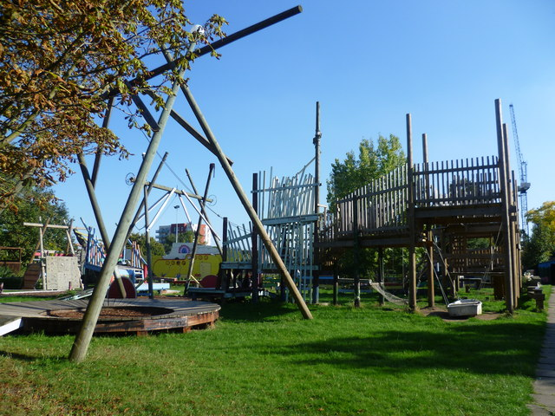We have been offered a fantastic deal from a local adventure playground company for some new equipment for the playground. Using the money we have raised from the recent bake sale, and because of the heavy discount we have been offered, we are able to buy similar equipment to that shown below.

Because of the size of it, the only place that will be big enough to house it will be the wildlife/pond area. We would have to drain the area and put safety tarmac down before being able to build upon it. We are asking for your feedback to this idea. How often is the wildlife/pond area used at the moment? Do you think the new play equipment will be a good idea?

Kind regards

Mrs Smith (change as necessary – you may want to check that the chair is ok with this!)

Chair of Governors

**Positive**

**Negative**

**Adventure Playground**



**Positive**

**Negative**

**Wildlife Area**

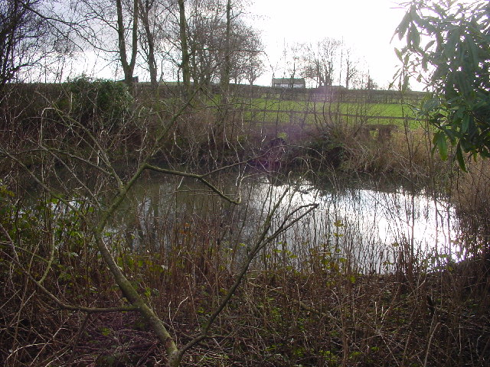

**Teachers’ Notes**

At the beginning of this block, ready for Session 4, grow some cress. Have two large boards and put a large mound of soil on both boards (the same amount on each), push it up into a peak. On one board, plant some cress seeds. Do not plant anything on the other board.

This block has one main science objective: recognise that environments can change and that this can sometimes pose dangers to living things.

This block can be as big or small as you decide to make it. It can be a school-sized project looking at environments within the school, or it can become a large community-sized project. This could be done by writing to the local council, asking about a space that the children could design. Perhaps you could invite a local planning officer in to talk to the children about what they have to do to minimise the impact on the environment before authorising a new building project. Someone from the Environment Agency could be invited to speak about testing local water. Or someone who has to carry out surveys that can explain what is done/prevented to help protect different species such as bats. A visit to the local recycling centre can help the children to understand the need to recycle. A day volunteering to tidy (litter picking, removing graffiti) a community environment and making it a better place for all living things is also a memorable thing for the children to be a part of.

This project could also take over much of the curriculum, particularly English, and will be greatly enhanced if done so. Letter writing to the local council and environment groups, persuasive writing and debating could all be done with this theme in mind. Speaking to other local residents about how they would like to see the space being used is a great activity. Before the final session, you will need some resources to plant/build, etc. in the area. It would be good to write to local businesses and ask for some donations of seeds, tools or physical help. They could be invited to see the progress of the area. The planning and creating of a local environment in Sessions 5 and 6 can be greatly enhanced if they form part of a larger D & T block – this could include using tools to build a bird box or a bug hotel. This block could also be linked to other curriculum areas, e.g. in RE learning about Buddhism and the interrelation between living things.

For the final session (where the class will be making a positive change to a local environment), it would be helpful to have as many adults as possible to help, particularly ones with building and landscaping skills.