SHAHUL KHAN

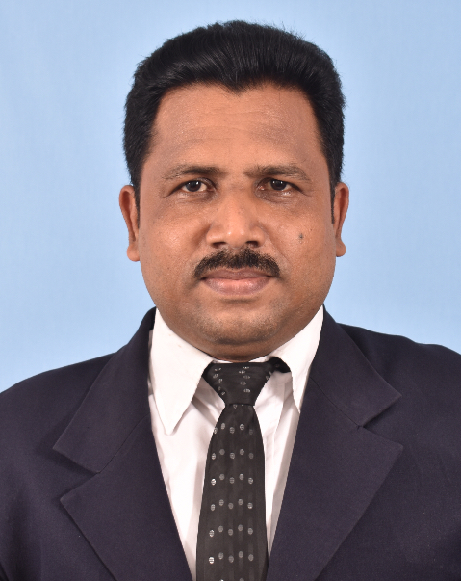

B.COM (Hons), CIMA, Diploma in English.

ENGLISH LANGUAGE TEACHER ABLE TO TEACH BUSINESS STUDIES & ACCOUNTING.

**Education**

In Sri Lanka

In Sri Lanka

In Qatar

In Sri Lanka

**(Total: 20 years)**

**Work**

**Experience**

**ALMISBAH NATIONAL SCHOOL - SRI LANKA. (2019.01.01 – 2024.01.31)**

* Assigned as English language teacher for primary and secondary students
* Assigned as BS & Accounting teacher for advanced level students.

**NASRIYA CENTRAL COLLEGE - SRI LANKA. (2015.01.01 – 2018.12.31)**

* Assigned English language teacher for ordinary level students.
* Assigned as BS teacher for advanced level students.

**ALSAQEE WATER COMPANY - ALSADH, QATAR. (2013.08.01 – 2015.12.20)**

* Employed as Senior Accountant.
* Handled all A/c related matters.
* Such as –

Financial Reporting , Accounting, Budgeting, Variance Analysis, Cash Flow Management, Statutory Compliance, Audit, Inventory, Fixed Assets, Accounts payable & Accounts receivable, ERP Implementation, Account software (Forcus), Payroll software (Micro Image & Greenwich) , Tally, Excel, Word, PowerPoint, Performance Video presentation, EOSB computation.

Business Agreements, Internal memos, Possess good Secretarial Skills, Risk Management, Logistics…

Additionally having skills on Leadership | Management | Strategy | Communication (written as well as oral) | Systematic | Self-motivated, Ability to free up CEO of all financial and playing advisory role to the CEO.

**NASRIYA CENTRAL COLLEGE - SRI LANKA. (2004.01.01 – 2013.07.31)**

* Assigned English language teacher for ordinary level students.
* Assigned as BS & Mathematics teacher for ordinary level students.

**NK/ABUKKAGAMA MUSLIM GOVNT SCHOOL- SRI LANKA. (1997.04.01 – 1998.05.30)**

* Worked as English Language Teacher for Ordinary level students.
* Worked as sports coach (Football and Volleyball).

**B.Com (Hons) Degree** (University of Peradeniya, Sri Lanka)

**CIMA** (Stage -1 successfully completed)

**Dip In English** (University of Peradeniya)

**Dip In Computer** (Millennium Academy)

+974 55344786

+974 55307961

+974 55344786 (W)

[shahul.khan123@gmail.com](mailto:shahul.khan123@gmail.com) [Linkedin/shahul Khan](https://lk.linkedin.com/in/ahamed-jaseer-a218931a3) 

Muntasa place, Doha, Qatar 

**Referees**

|  |  |
| --- | --- |
| **1** | **2** |
| **Group Accountant** – Mr. A.M.M. Nifras. | **Principal** – Mr. S.L. Anver, |
| Sharaka Holdings Group, Qatar. | Chi/ Almisbah National School, Madampe. |
| TP: +974 44442202, Ext: 232 | TP: 0094 322248920, Mobile: 0094 774497393 |
| Web: sharakaholdings.com | Email: almisbah1930@gmail.com |

This is to certify that all above particulars furnished by me are true and correct to the best of my knowledge.

Yours faithfully,

**Shahul Khan.**

**Race -** Muslim

**Nationality -** Sri Lankan

**Age -** 47

**Civil Status -** Married

**Children -** 3

**Passport No -** N 10506380

**Driving License No -** AO 11796642

**Personal**

**Details**

**English -** Fluent in speaking & writing

**Tamil -** Fluent in speaking & writing

**Sinhala -** Fluent in speaking & writing

**Malayalam -** Speaking (Basic)

**Hindi -** Speaking (Basic)

**Arabic -** Reading (Basic)

**Languages**