**Wafa Ahmad Moghrabi**

**Contact & Personal Information**

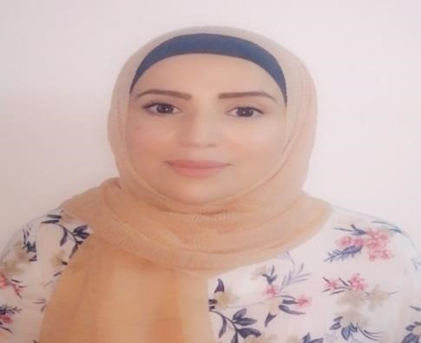 DOHA, QATAR.

EMAIL ADDRESS: wafaalmoghrabi506@gmail.com

MOBILE PHONE: +974 - 50230942

BORN ON: 30 November 1987

GENDER: Female

MARITAL STATUS: Married

NATIONALITY: Jordanian COUNTRY: Irbid, Jordan

# Objective

• I have a BSc in economy and +2 years of experience in marketing services. Seeking to leverage my technical and professional expertise to grow in the new role of economy field at your company.

# Education

* Bachelor Degree in Business and Finance Economy (71.6), Yarmouk University, Irbid, Jordan,2011.

* High School from Mutah High School for Girls (74.5), Karak, Jordan, 2007.

# Work Experience

* Marketing at Amman Stock Exchange (May 2010 to September 2011).
* Cashier at Burger King (May 2007 to December 2009).
* Manger and teacher at Alia Cultural Center (April 2017 to January 2019).

# Skills

* Learning Quickly.
* Flexibility.
* Team Work.
* Time Management.
* Presentation Skills.
* Communication Skills.
* Computer skills (Microsoft Office).
* Use multiple applications and websites.
* Confident with strong personality.
* Work under pressure for long hours.

# Languages

* English
* Arabic